

Draw it or Lose it

# **CS 230 Project Software Design Template**

Version 1.2

## Table of Contents

**CS 230 Project Software Design Template**1

**Table of Contents**2

**Document Revision History**2

**Executive Summary**3

**Design Constraints**3

**System Architecture View**3

**Domain Model**3

**Evaluation**5

**Recommendations**8

## Document Revision History

| Version | Date | Author | Comments |
| --- | --- | --- | --- |
| 1.0  1.1  1.2 | 03/21/2021  04/04/2021  04/18/2021 | Kevin Raddatz  Kevin Raddatz  Kevin Raddatz | Initial Design  Expanded Analysis and Evaluation of Platform/Development requirements.  Added Client Reccomendations |

**Instructions**

Fill in all bracketed information on page one (the cover page), in the Document Revision History table, and below each header. Under each header, remove the bracketed prompt and write your own paragraph response covering the indicated information.

## Executive Summary

The Gaming room requires a Web-based launch of their game ‘Draw it or lose it’. The solution being offered is a Java application written using Object oriented programming principles to solve the problem. The original android application must be scaled up to meet the requirements of a web-based game, such as one or more unique teams that can run at one time.

## Design Constraints

Special attention will need to be given to making sure the application functions on web browsers on all platforms (Linux, Windows, Ios, Android, Etc). The correct framework must be used for web based development and extensive testing should be carried out to ensure that the software functions correctly when deployed in a web based environment. All devices that are required to run the device must have the Java Runtime Environment installed and up to date.

## System Architecture View

Please note: There is nothing required here for these projects, but this section serves as a reminder that describing the system and subsystem architecture present in the application, including physical components or tiers, may be required for other projects. A logical topology of the communication and storage aspects is also necessary to understand the overall architecture and should be provided.

## Domain Model

The UML class diagram below shows the relationship between classes. The Team, Player, and Game classes all Inherit from the Entity class. Inheritance is an OOP principle present in the program. The ProgramDriver class uses data from the Game class, as well as having a One-way association with SingletonTester. The Classes GameService, Game, Team, and Player all have an association relationship between the classes.

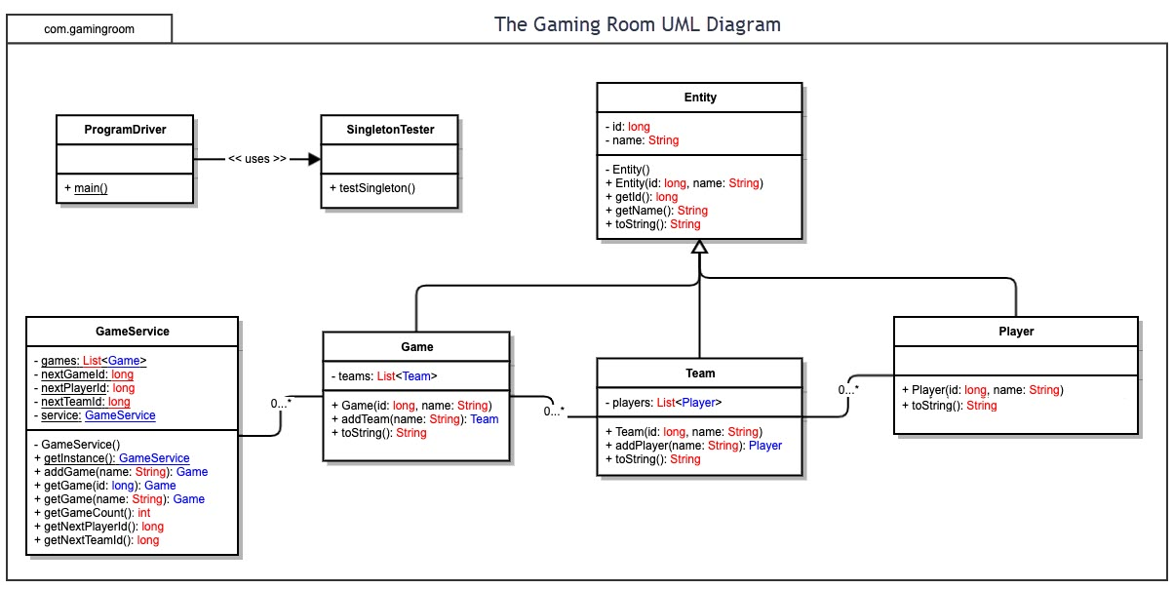

## Evaluation

As the Software being developed is intended for Web browser-based deployment, the platform the browser is running on does not make a huge difference. Therefore, all characteristics/functionality of the application will need to be the same across all platforms. Java is the best choice for a cross platform project such as this as the code can be executed by a virtual machine (JVM) on all devices. As the same application can be written for multiple platforms, it is not necessary for the project to include a huge development team. This project should be able to be conducted using one development team, although it is imperative that the development team include members experienced in the deployment of Java application on IOS and Android. For this project, licensing costs are not much of a concern, the only special licensing costs that would be required are an Apple Developer license ($99/Yr) as well as a one-time payment of $25 to Google for a developer account for Android. Server Licensing requirements are however more expensive for the customer. Server licenses can range from $20-$125 a month (Windows Server). All other development tools chosen are available to use free of charge.

| **Development Requirements** | **Mac** | **Linux** | **Windows** | **Mobile Devices** |
| --- | --- | --- | --- | --- |
| **Server Side** | Advantages: Faster Access speeds than Mobile as internet speeds likely to be faster than typical 4G/ LTE  Disadvantages:  Slower Access Speeds than downloaded app as Web App Accessed from server through the Internet  Web Application will be hosted on the Customer’s server and accessed Via the Web browser on a MacOs device. | Advantages: Faster Access speeds than Mobile as internet speeds likely to be faster than typical 4G/ LTE  Disadvantages:  Slower Access Speeds than Downloaded App as web App Accessed from server through the Internet.  Web Application will be hosted on the Customer’s server and accessed Via the Web browser on a Linux device. | Advantages: Faster Access speeds than Mobile as internet speeds likely to be faster than typical 4G/ LTE  Disadvantages:  Slower Access Speeds than downloaded app as App Accessed from server through the Internet.  Web Application will be hosted on the Customer’s server and accessed Via the Web browser on a Windows Device. | Advantages: More portable and likely to have a simpler design. A downloaded version on  Disadvantages:  Slower access over Mobile Networks as opposed to WiFi/Wired connections. Hardware not as good as desktops.  According to Documentation from Apple/Android, both platforms are capable of server-based deployment. Web Application will be accessed via Web Browser and hosted on customers servers. |
| **Client Side** | Software to be developed to be runnable on web browsers available for MacOS.  Application should run as a modern and responsive HTML interface inside a modern browser. For MacOS, Safari will be used as it is native to MacOS. | Software to be developed to be runnable on web browsers available on Linux  Application should run as a modern and responsive HTML interface inside the web browser. | Software to be developed to be runnable on web browsers available on Windows  Application should run as a modern and responsive HTML interface inside the web browser. | Software being developed must be runnable on mobile web browsers as well as have a UI built for mobile devices.  Applications available for download on both IOS and Android devices.  Application should also be accessible through Web Browser as well With a modern and responsive HTML interface. |
| **Development Tools** | * Java (Language) * Maven * Eclipse IDE * Computer   Capable of running the development Environment.  Other Tools: Web Browser for testing of web application.  Java Development Kit. | * Java (Language) * Maven * Eclipse IDE * Computer   Capable of running the development Environment.  Other Tools: Web Browser for testing of web application.  Java Development Kit. | * Java (Language) * Maven * Eclipse IDE * Computer   Capable of running the development Environment.  Other Tools: Web Browser for testing of web application.  Java Development Kit. | * Eclipse IDE * Computer   Capable of running the development Environment.  The Java language can be used to write the web application for Web based as well as downloadable application.  Other Tools:  Android/IOS development tools for deployment (XCode, Android Studio, Etc)  Java Development Kit.  Licensing Costs:   * Android Development fees: $25 * Apple Developer Program: $99/Yr |

## Recommendations

Analyze the characteristics of and techniques specific to various systems architectures and make a recommendation to The Gaming Room. Specifically, address the following:

**Recommendation:**

It is recommended that The Gaming Room use a Windows PC based server system. Draw it or Lose it should be stored on this Windows Based Server. A Server based on a Windows operating platform such as Windows server will be simplest and most economical way to implement this server, as the hardware/software is widely available. Another thing that makes this the most attractive option is that the windows platform has a wider variety of professionals that specialize in maintaining a server run on this platform, meaning that it will cost less to hire a professional to maintain this. This is in contrast to a server hosted on a linux or MacOS machine. A windows-based server will also contain the necessary computing power to offer access to many users trying to play the game at one time across all devices. A Windows PC was chosen as opposed to a mobile device as the hardware will be a much better fit for this kind of application.

To optimize memory and storage across the server and client devices, The Gaming room should offer a downloadable image package for users to download. This will be stored locally on the users system. Draw it or lose it will be stored on the main server and accessed via a modern web browser such as Chrome, safari, or firefox. Memory management will be the most important on the user devices. The use of memory should be as minimal as possible and only time sensitive and necessary files should be stored in the memory. As stated earlier, the downloadable image pack for the game would be stored in the computers storage while the program would send the necessary images to the computers memory temporarily. They would then be removed to clear space. The Server’s storage will need to be able to handle large scale storage of user data. The recommendation here is to store necessary user data in cloud storage. This will protect user data in the event of hardware failure at the gaming room as well as protect it from outages.

Security is an important consideration for Draw it or Lose it. It is recommended that the website require sign up/password protection in order to access the application. Anytime user data needs to be sent from a device back to the server, it should be encrypted to a high level. All sensitive user data should be encrypted on the server and only accessible by authorized individual.

The final recommendation for the gaming room is to integrate a program such as maven into the Java application to facilitate running the program stored on the server on the client devices. Maven acts as a middleman for this type of program. In the event of an outage for the draw it or lose it server, the web based version would be out of commission while the downloadable version could still be functionable.